CONTENTS

1. Introduction
2. Objectives
3. Back-End-Design
4. Front-End-Design
5. Output
6. Software requirements
7. Hardware requirements
8. Modules
9. Conclusion

10. Bibliography

INTRODUCTION

Tour Management system is a dynamic website for tourism business. It is dynamic and responsive web design. It is also called travel technology solution for agencies and tour operation. Nearly Everyone goes on a vacation for this “a Tourism management system” would play a vital role in planning the perfect trip. The tourism management system allows the user of the system access all the details such as location, events, etc. The main purpose is to help tourism companies to manage customer and hotels etc. The system can also be used for both professional and business trips. The proposed system maintains centralized repository to make necessary travel arrangements and to retrieve information easily. Tourists are more attractive for cultural diversity of the world. Bangladesh is one of the most beautiful country in the south Asia. Rangamati, Cox’s Bazar, Saint-Martin, Sundarbans, Sylhet, Moulvibazar, are the famous tourist place in Bangladesh as well as in Malaysia, Singapore, Bangkok, Maldives, Nepal, India have attractive tourist places.

OBJECTIVES

* This application is develop to provide best travelling services to the customers and travel agents. We have developed tours and travel management system to provide a search platform where a tourist can find their tour places according to their choices.
* This system also helps to promote responsible and interesting tourism so that people can enjoy their holidays at their favourable places.
* This system also helps to develop tourism with different cultures so that enrich the tourism experience and build pride.
* This system is Developed to create and promote forms of tourism that provide healthy interaction opportunities for tourists and locals and increase better understanding of different cultures, customs,lifestyles,traditional knowledge and believes. This system also provides a better way to connect with various events.

**BACK-END DESIGN**

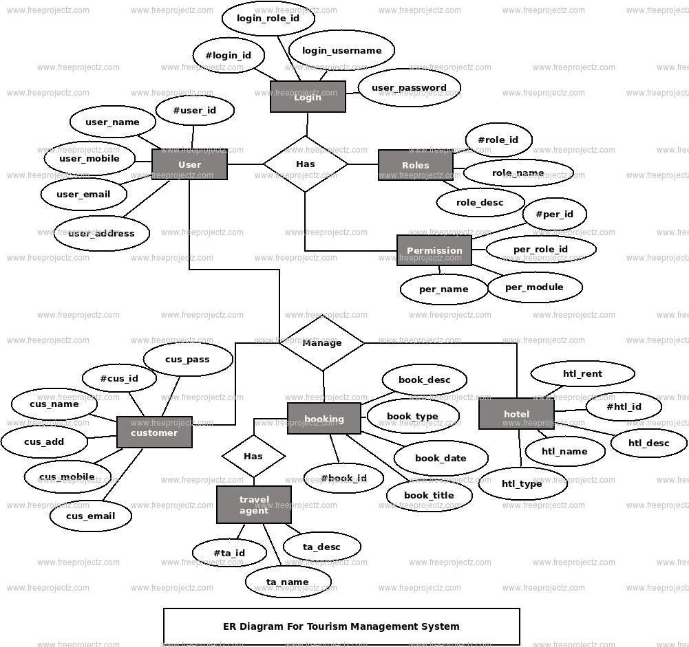

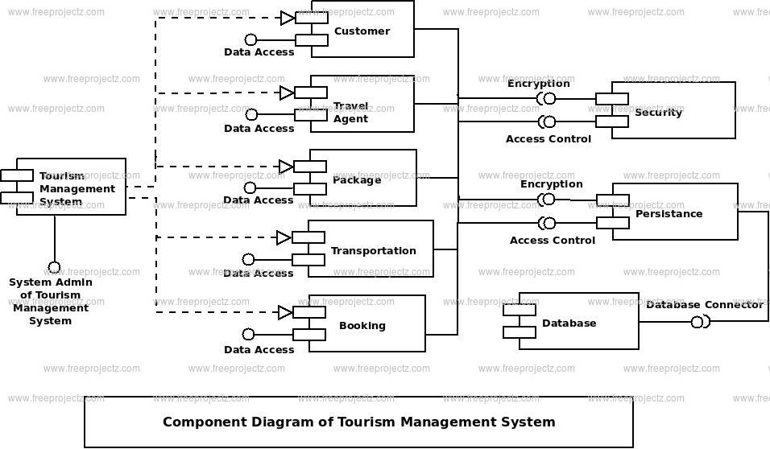

**FRONT-END ANALYSIS**

**FRONT-END WEB DEVELOPMENT DETAILS**

* **HTML**provides the basic structures of sites, which is enhanced and by other technologies like CSS
* **CSS**  is used to control presentation , formatting and layout

**HTML**

HTML is the core of every web page, regardless the complexity of a site or number of technology involved. It’s an essential skill for any web professional. It’s the starting point for anyone learning how to create content for the web professional. It’s surprisingly easy to learn.

**CSS**

CSS stands for Cascading style sheets. This programming language Dictates how the HTML elements of website should actually appear on the frontend of the page.

**BACK-END: PHP, MySQL**

**1.PHP:** Hypertext Pre-processor (PHP) is technology that allows software developers to create dynamically generated web pages,in HTML, XML or other document types, as per client request. PHP is open source software.

**2. MySQL:** MySQL is a database, widely used for accessing querying, updating and managing data in databases.

**SOFTWARE REQUIREMENTS:**

**XAMPP SERVER**

**WEB TECHNOLOGIES:HTML, CSS**

**WEB SERVER: APACHE**

**DATABASE: MYSQL**

**HARDWARE REQUIREMENTS:**

**HARDWARE: PENTIUM**

**RAM: 1GB**

**FRONTEND: HTML AND CSS**

**BACKEND DATABASE: MYSQL**

**MODULES:**

The system is proposed to have the following modules:

ADMINISTRATOR MODULE:

This module provides administrator related functionality administrator manages all information and has access rights to add, delete, edit and view the data related to places, travels, routes, bookings, etc.

TRAVELS MODULE:

This module provides the details of various travel agencies. A user can select the appropriate agency depending on convenience accessibility.

ROUTES MODULE:

This module provides information related to various routes connecting sources and destinations. For each route, information such as source, destination, fare, reservation details, pick up points etc are provides.

Only administrator can add, delete, edit and manage the data. Users can only view the information.

RESERVATIONS MODULE:

This module provides functionalities that allow user to book tickets or cancel previously booked tickets. The module maintains the details of all reservations made so far and allows administrator to either confirm or reject the bookings.

TESTIMONIALS MODULE:

Users of this application can post their opinions, complaints and suggestions regarding this portal and services to the administrator. Accordingly, the administrator can take various steps to act on the complaints and suggestions.

**PLAGIARISM CHECKER**

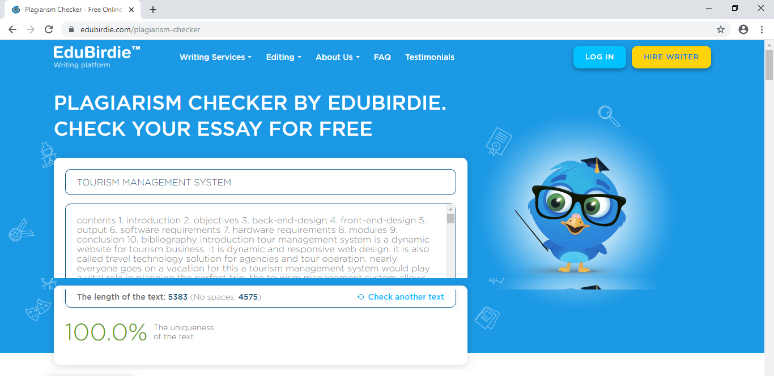

**COST ESTIMATION**

Project cost estimation scares a lot of people. They don’t know how much something will cost, but they know whatever value they give, they will be held to it by their manager.

The challenge with estimating is that it always involves some uncertainty. Some of the factors that contribute to this uncertainty include….

* **Experience with Similar Projects:** The less experience you have with similar projects, the greater the uncertainty. If you've managed similar projects, you will be able to better estimate the costs of the project.
* **Planning Horizon:** The longer the planning horizon, the greater the uncertainty. The planning horizon you are considering may be the whole project or just a certain phase. Either way, you will be able to better estimate costs for the time periods that are closer to the present.
* **Project Duration:** The longer the project, the greater the uncertainty. This is similar to planning horizon in the sense that if a project is of a shorter duration you are more likely to account for most of the costs.
* **People:** The quantity of people and their skill will be a huge factor in estimating their costs. Early in the project, you may not even know the specific people that will be on the project. That will increase the uncertainty of your cost estimates.

Fortunately, there are some tools and techniques used by professional project managers that you can use to develop more accurate cost estimates...

**EXPERT *JUDGEMENT***

Expert judgment uses the experience and knowledge of experts to estimate the cost of the project. This technique can take into account unique factors specific to the project. However, it can also be biased.

**ANALOGOUS ESTIMATING**

Analogous estimating uses historical data from similar projects as a basis for the cost estimate. The estimate can be adjusted for known differences between the projects. This type of estimate is usually used in the early phases of a project and is less accurate than other methods.

**PARAMETRIC ESTIMATING**

Parametric estimating uses statistical modelling to develop a cost estimate. It uses historical data of key cost drivers to calculate an estimate for different parameters such as cost and duration. For example, square footage is used in some construction projects.

**BOTTOM-UP ESTIMATING**

Bottom-up estimating uses the estimates of individual work packages which are then summarized or "rolled up" to determine an overall cost estimate for the project. This type of estimate is generally more accurate than other methods since it is looking at costs from a more granular perspective.

**THREE-POINT ESTIMATES**

Three-point estimates originated with the [***Program Evaluation and Review Technique (PERT)***.](https://amzn.to/2RJ5Ndw)This method uses three estimates to define an approximate range for an activities cost: Most Likely (Cm), Optimistic (Co), and Pessimistic (Cp). The cost estimate is calculated using a weighted average: Cost Estimate = (Co + 4Cm + Cp)/6

**RESERVE ANALYSIS**

Reserve analysis is used to determine how much contingency reserve, if any, should be allocated to the project. This funding is used to account for cost uncertainty.

**COST OF QUALITY**

Cost of Quality (COQ) includes money spent during the project to avoid failures and money spent during and after the project due to failures. During cost estimation, assumptions about the COQ can be included in the project cost estimate.

**PROJECT MANAGEMENT ESTIMATING SOFTWARE**

Project management estimating software includes cost estimating software applications, spreadsheets, simulation applications, and statistical software tools. This type of software is especially useful for looking at cost estimation alternatives.

**VENDOR BID ANALYSIS**

Vendor analysis can be used to estimate what the project should cost by comparing the bids submitted by multiple vendors.

Using some of these tools and techniques when you're planning your project can help with your project building[.](https://www.project-management-skills.com/project-budgeting.html)

* **TABULAR COLUMN**

|  |  |
| --- | --- |
| **SOFTWARE REQUIREMENTS** | **RS.350** |
| **SITE HOSTING** | **RS.300** |
| **MAINTENANCE** | **RS.100 PER MONTH** |
| **DOMAIN COST** | **RS.100 PER MONTH** |
| **TOTAL** | **RS.850 INITIALLY AND RS.500 THERE AFTER EVERY MONTH** |

**CONCLUSION**

While developing this project we have learnt a lot about HTML/CSS/PHP/MYSQL and working with database management, we have also learnt how to make the application user friendly by hiding the complicated parts of it from the users.

During the development process, we studied carefully and understood the criteria for making for software more demanding, we also realized the importance of maintaining a minimal margin for errors.

**BIBILOGRAPHY**

It has been a matter of immense pleasure, honour, and challenge to have this opportunity to take up this project and complete it successfully.

We have obtained information from various resources to design and implement our project. We have acquired most of the knowledge from the internet.

The following are some of the resource:

* Prof. Margesh
* [www.tutorialspoint.com](http://www.tutorialspoint.com)
* Google and YouTube tutorials